Source (Asal) | Destination (Tujuan) | Action | Business Reason (Alasan Bisnis)
Penjualan | SDM | Permit | Requirement: Case B explicitly states these two must coordinate.
Penjualan | Gudang | Permit | Assumption: Sales needs to check stock/inventory in real-time before selling.
Penjualan | IT / Manajemen | Block | Sales staff should not access server configs or sensitive management files.
SDM | Penjualan | Permit | Requirement: Coordination with Sales (recruitment for sales, commissions, etc).
SDM | Gudang / IT / Manaj | Block | HR data is confidential; no need to access warehouse or servers.
Gudang | Penjualan | Permit | Logic: To reply to stock requests from Sales.
Gudang | IT | Permit | Logic: Warehouse systems often need IT maintenance/updates.
Gudang | SDM / Manajemen | Block | Warehouse staff should not see payroll (SDM) or executive data.
Manajemen | IT | Permit | Logic: To access reports or report technical issues to IT.
Manajemen | Penjualan / Gudang / SDM | Block | Executives review reports, they don't log into cash registers or barcode scanners directly.
IT (Server) | ALL | Permit | Logic: IT is the "Super Admin". They need to fix problems in every department.
Source (Asal) | Destination (Tujuan) | Action | Business Reason (Alasan Bisnis)

! --- COPY INTO ROUTER UTAMA ---
enable
configure terminal

! 1. ACL for PENJUALAN (Allow to SDM & Gudang only)
access-list 100 remark ACL_PENJUALAN_OUT
access-list 100 permit ip 192.168.10.0 0.0.0.63 192.168.10.64 0.0.0.31
access-list 100 permit ip 192.168.10.0 0.0.0.63 192.168.10.128 0.0.0.15
! (Implicit Deny blocks IT & Manajemen automatically)

! Apply to Interface connected to Switch Penjualan
interface Eth0/3/0
ip access-group 100 in
exit
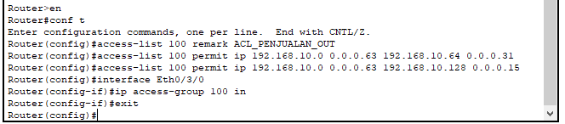
! 2. ACL for SDM (Allow to Penjualan only)
access-list 101 remark ACL_SDM_OUT
access-list 101 permit ip 192.168.10.64 0.0.0.31 192.168.10.0 0.0.0.63
! (Implicit Deny blocks Gudang, IT, Manajemen automatically)

! Apply to Interface connected to Switch SDM
interface Fa1/1
ip access-group 101 in
exit
end
write memory
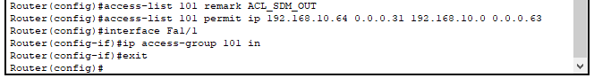
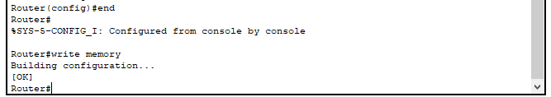

! --- COPY INTO ROUTER GUDANG ---
enable
configure terminal

! ACL for GUDANG (Allow to Penjualan & IT only)
access-list 100 remark ACL_GUDANG_OUT
access-list 100 permit ip 192.168.10.128 0.0.0.15 192.168.10.0 0.0.0.63
access-list 100 permit ip 192.168.10.128 0.0.0.15 192.168.10.96 0.0.0.31
! (Implicit Deny blocks SDM & Manajemen)

! Apply to Interface connected to Switch Gudang
interface Fa1/1
ip access-group 100 in
exit
end
write memory
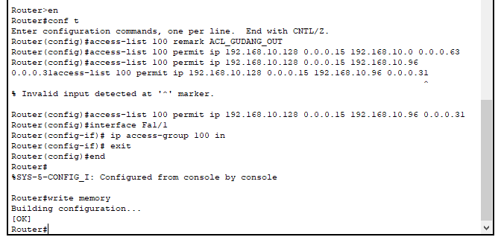

! --- COPY INTO ROUTER MANAJEMEN ---
enable
configure terminal

! ACL for MANAJEMEN (Allow to IT only)
access-list 100 remark ACL_MANAJEMEN_OUT
access-list 100 permit ip 192.168.10.144 0.0.0.31 192.168.10.96 0.0.0.31
! (Implicit Deny blocks Penjualan, SDM, Gudang)

! Apply to Interface connected to Switch Manajemen
interface Fa1/1
ip access-group 100 in
exit
end
write memory
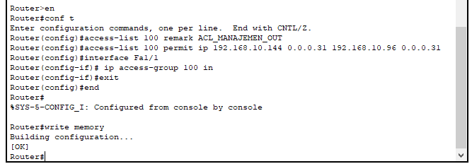

! --- ROUTER SERVER ---
enable
configure terminal
! Allow IT to go everywhere
access-list 100 permit ip any any
interface Fa1/1
ip access-group 100 in
exit
end
